Complexity Analysis:
1. Finding the rightmost low point, p0 takes O(n) time complexity
2. Sorting according to the slope of the points with respect to the p0 point takes O(nlogn)
3. Every point is then pushed once into the stack making O(n)
4. Some points are popped from stack O(n-h)
This results in a time complexity of O(nlogn) for the Graham’s Scan.
Test Case Design:
Graham’s scan performs better than gift wrapping, whenever h>log(n) [assuming sorting always takes nlog(n)]
Test1:
All points on the Convex Hull
8
0 0
1 0
2 0
2 1
2 2
1 2
0 2
0 1
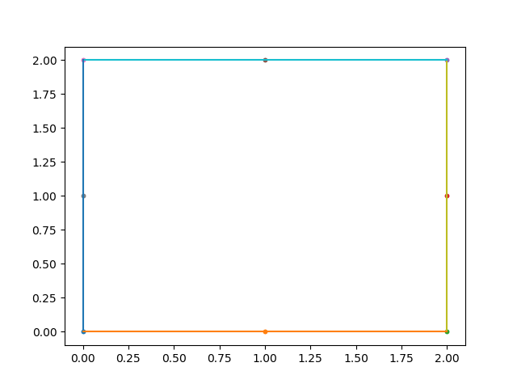
Test2:
Gift wrapping performs better than Graham’s scan when there are lots of internal points:
50
0.253131410024 0.110753875413
2.49530634455 3.70124959709
3.52572819247 2.57987398065
0.330690248905 0.672088185311
1.93394314577 0.0041499045555
0.654445556939 1.37846223615
4.8071355916 3.62989405046
3.79621563405 4.26385480163
3.70159614973 2.11419401505
0.370765765947 1.9252374957
4.68466433294 3.06808861731
2.41939938486 3.60945507258
4.79717696059 3.66691593121
3.77122750264 0.455533939884
3.59179760358 1.70562926061
4.02040554802 3.11238125091
3.86008319617 0.377789460229
0.17252645466 0.605391596455
0.166698151584 2.91992118635
3.71020457232 3.41204538081
3.14553038571 0.98614479992
3.0012296688 4.90582530568
2.75376285132 0.696382998913
4.19804003369 4.11019824411
1.63501856957 4.71258526395
2.23320009427 1.2473129683
1.22935864051 0.654533276773
1.71842422364 0.734833801697
0.834330856251 1.16759906961
2.84337364459 4.45918076254
3.10347262726 1.24141039599
0.0898276330552 2.99338077765
0.736727171536 2.83083735527
3.50519124909 2.24417338787
4.49880350033 1.86010207348
4.27782064745 0.846124130947
3.30739864236 0.5067132817
2.42701100347 2.13701292131
0.756617181993 3.99297828101
0.111449152045 2.01298587114
0.387289458685 4.0654245881
1.47768576753 1.0562778881
3.90973269185 3.15067569543
2.59626269937 3.44496203906
4.91628548334 4.70304808786
1.30534639555 4.77531669993
0.878524745018 0.598038298139
2.46022340835 1.03896353777
2.40485194623 2.82781297238
1.24201935977 4.16164746999
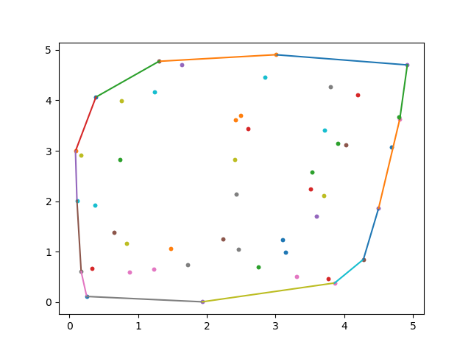
Test3:
Graham’s scan performs better than Quick Hull whenever there is one sided distribution of points such as:
9
0 1
1 0
2 1
4 1
3 1.5
3 3.5
4 2
2 4
1 2
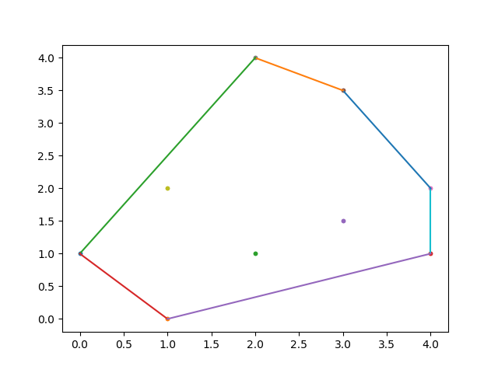
Test4:
Quick Hull performs better than Graham’s scan whenever the points are scattered uniformly.
Like in this case:
30
2.21800414333 4.65231238632
0.891444095185 1.21769994879
2.44129812769 3.2327754047
4.67862769513 4.42031911291
0.920382589551 4.67280325014
4.9551141641 1.35727076695
4.77035360038 0.895094454664
1.87010679498 3.71235816769
3.52199098796 3.01110161426
3.41336139331 2.31051721281
2.53766047609 3.16823898622
4.59346993894 3.61169168916
2.84101016743 0.743158543865
2.81200779754 3.54564990846
4.65558673353 2.09617156989
3.82711615187 0.350675673343
0.0487278651357 2.54848605096
3.8661692024 1.22682395592
4.437077888 3.5279018927
3.84436395812 3.91129251588
2.63562706443 2.99143924917
0.64330599608 4.39747221503
2.68661918394 3.52703030345
4.85187070407 2.81638857029
1.83687415337 2.4867164016
3.32675999012 3.74803882326
2.41368583087 1.5830413628
2.49334242148 3.20186285478
1.59920548447 3.47225739004
2.63648936692 0.544878477042
